- Postmark summary:

For this benchmark we used the parallel mpi version that can be found at:
http://michail.flouris.net/2008/06/parallel-postmark-benchmark/.

# mpirun -np 32 -hostfile hostfile /root/mpipostmark-1.5.1/postmark pmtest
Following is the pmtest file used highlighting the 3 parameters we modified between the tests:
set location /mnt/lustre1
set number 20000
set transactions 1000
set subdirectories 3
set size 32768 400000
set bias read 16384
set write 16384
set partition prefix
set report cluster
run
quit

- 10000, 1000, 3
Total files | Tested FS | File Trans/s | File Creates/s | File Reads/s | File Append/s | File Delete/s | Read MB | Write MB | Read MB/sec | Write MB/s
335840 | lustre2 | 2108 | 4344 | 1085 | 1068 | 4344 | 3338 | 71443 | 44 | 964

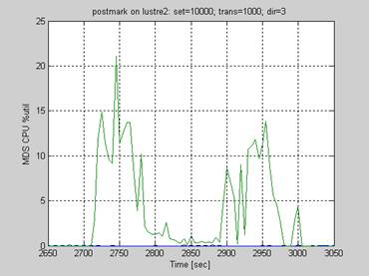

- 20000, 1000, 3
Total files | Tested FS | File Trans/s | File Creates/s | File Reads/s | File Append/s | File Delete/s | Read MB | Write MB | Read MB/sec | Write MB/s
656064 | lustre1 | 1066 | 3928 | 549 | 515 | 3927 | 3477 | 137296 | 21 | 841
656064 | lustre2 | 1777 | 5151 | 1049 | 984 | 5151 | 3477 | 137296 | 28 | 1103

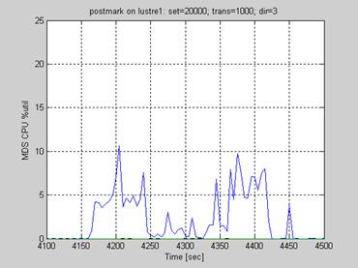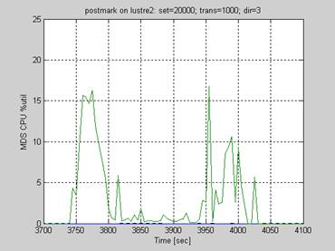

- 20000, 1000, 30
Total files | Tested FS | File Trans/s | File Creates/s | File Reads/s | File Append/s | File Delete/s | Read MB | Write MB | Read MB/sec | Write MB/s
656064 | lustre2 | 2133 | 4887 | 1110 | 1041 | 4887 | 3477 | 137296 | 26 | 1047


